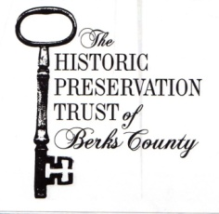
Invites You To Our Annual Gala Dinner

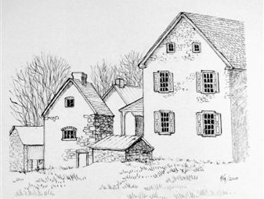
A Celebration of the Keim Homestead: A National Historic Landmark
Saturday, November 4, 2017 • 6-9pm
Reading Public Museum
500 Museum Road, Reading, PA 19611

Join us for a beautiful evening of good food & drink as we celebrate the important work of the Trust. A brief presentation & silent auction will follow dinner. Ticket includes dinner and two drinks.

All proceeds benefit the Trust, a non-profit organization dedicated to acquiring, preserving, and maintaining historically and architecturally significant properties in Berks County, PA. The Trust seeks to foster community involvement and support in promoting awareness and appreciation for the role their eight historic buildings played in our American history.
- - - - - - - - - - - - - - - - - - - - - - - - - - - - - - - - -
R.S.V.P.
Please reply by Oct. 21

M ________________________________________________

□ Accepts with Pleasure
_____ HPT Member @ $60 _____ Non-Member @ $70
□ Declines with Regret □ Declines, but Happy to Make a Donation of $________

Menu Choices: □ Beef ___ □ Crab Cake ___ □ Vegetarian ___

Send to: P.O. Box 245, Douglassville, PA 19518. Tickets may also be purchased on our website at www.historicpreservationtrust.org.

